
HASS  Australia in the past | Year 6 | Unit 1
Assessment task — Australia in the past: Model response

Task
Purpose of assessment: To explain the significance of key people, events, institutions and processes to the development of the Australian nation.
Part A: Examining key figures, events and ideas that led to Federation
Students will:
- Sequence information about events and the lives of individuals in chronological order.
- Recognise the contribution of individuals and groups to the development of Australian society since Federation.
- Describe the cause and effect of events on society.
- Locate and collect useful data and information from primary and secondary sources.
- Examine the key figures, events and ideas that led to Australia’s Federation and Constitution.
Part B: Investigating democratic Australia
Students will:
- Generate alternative responses to an issue, using criteria to make decisions and judgments and consider advantages and disadvantages of preferring one decision over another.
- Investigate the key institutions, people and processes of Australia’s democratic and legal system.
- Present ideas, findings, viewpoints and conclusions in a range of communication forms that incorporate source materials.
- Reflect on learning to propose personal and/or collective action in response to an issue or challenge, and predict the probable effects.
Part A: Examining key figures, events and ideas that led to Federation
- Sequence three key events in the life of Sir Henry Parkes in chronological order.
Year | Event
1850 | - Formed the Australian League (group dedicated to establishing Australian republic)
1872 | - Elected Premier of NSW for the first time
1889 | - Tenterfield Oration
- List the social, political and/or economic effects of the Tenterfield Oration.
- inspired people to dream | - Australasian Federation Conference
- Corowa Conference — linked to trade and transport problems in Corowa | - Federation of Australia — growth of the nation
- Generate additional criteria to assess the issue — Should ‘Father of Federation Day’ be introduced to recognise the achievements of Sir Henry Parkes?
Use tally marks to reflect each group member’s point of view for each criterion.
Criteria | Agree | Neutral | Disagree
Sir Henry Parkes was a motivational leader. | II | I | I
Not everyone deserves a day of celebration. | II |  | II
Henry Parkes deserves the title ‘Father of Federation.’ | II | I
Henry Parkes made a speech but the events that followed were more significant (MS). | III |  | I
Other leaders don’t have public holidays. (RT) | IIII
Doesn’t recognise any other aspect of our democratic and legal systems (e.g. Magna Carta/Westminster).(SS) | II |  | II
- Write an argument to support your point of view on the Father of Federation Day Bill. Use sources to justify your argument.
Topic sentence (what is this argument about?)  Explain using specific events and details.  Elaborate using evidence from sources (primary and secondary).  Link the person, group or event to the historical significance (past and present). | Answers will vary:  After more than 100 years since his death, Sir Henry Parkes is still remembered as Australia’s ‘Father of Federation’ because of his determination to inspire the Federation of the colonies (as suggested in 1900, Cotton, H.). As Premier of NSW, Parkes used his way with words to motivate the country at the Tenterfield Oration of 1891, calling for ‘one great and united people’ (1889, Parkes, H.).  However, this was just one small part of a huge chain of events that caused Federation. If we pass a Bill to celebrate ‘Father of Federation Day’, why not celebrate ‘Corowa Conference Day’ (31st July) and ‘Day of Constitution’ (1st January) too? A day in honour of Parkes would not only insult the traditional owners of this land but it would not recognise many other foundations of Australia that Parkes fought so hard to shape, such as the Westminster influence in our government (British Parliament, House of Commons, UK).  Sir Henry Parkes is a significant individual in Australian history and deserves the title ‘Father of Federation’ – this does not mean he deserves a public holiday.
- Identify the sources you have used in your argument. An example has been provided.
Burrows, N. (1899) ‘Little Nation’, The South Australian Chronicle, Adelaide
Anonymous (1896) ‘The Great Work For Friday’ political cartoon, The Argus, Melbourne
Anonymous House of Commons UK Courtesy of British Parliament
Cotton, H. (1900) Sir Henry Parkes
Parkes, H. (1889) Tenterfield Oration. N.S.W: Courtesy of National Library of Australia
Part B: Investigating democratic Australia
Your task
Identify a day of recognition that you think is important enough for a public holiday.
In your group you will:
- identify possible days of recognition and identify their purpose
- use criteria to choose one day
- develop arguments to justify your decision
- present your idea and viewpoints.
- Identify and explain days of recognition that could be raised in each type of Parliament. Use initials to identify each person’s idea.
National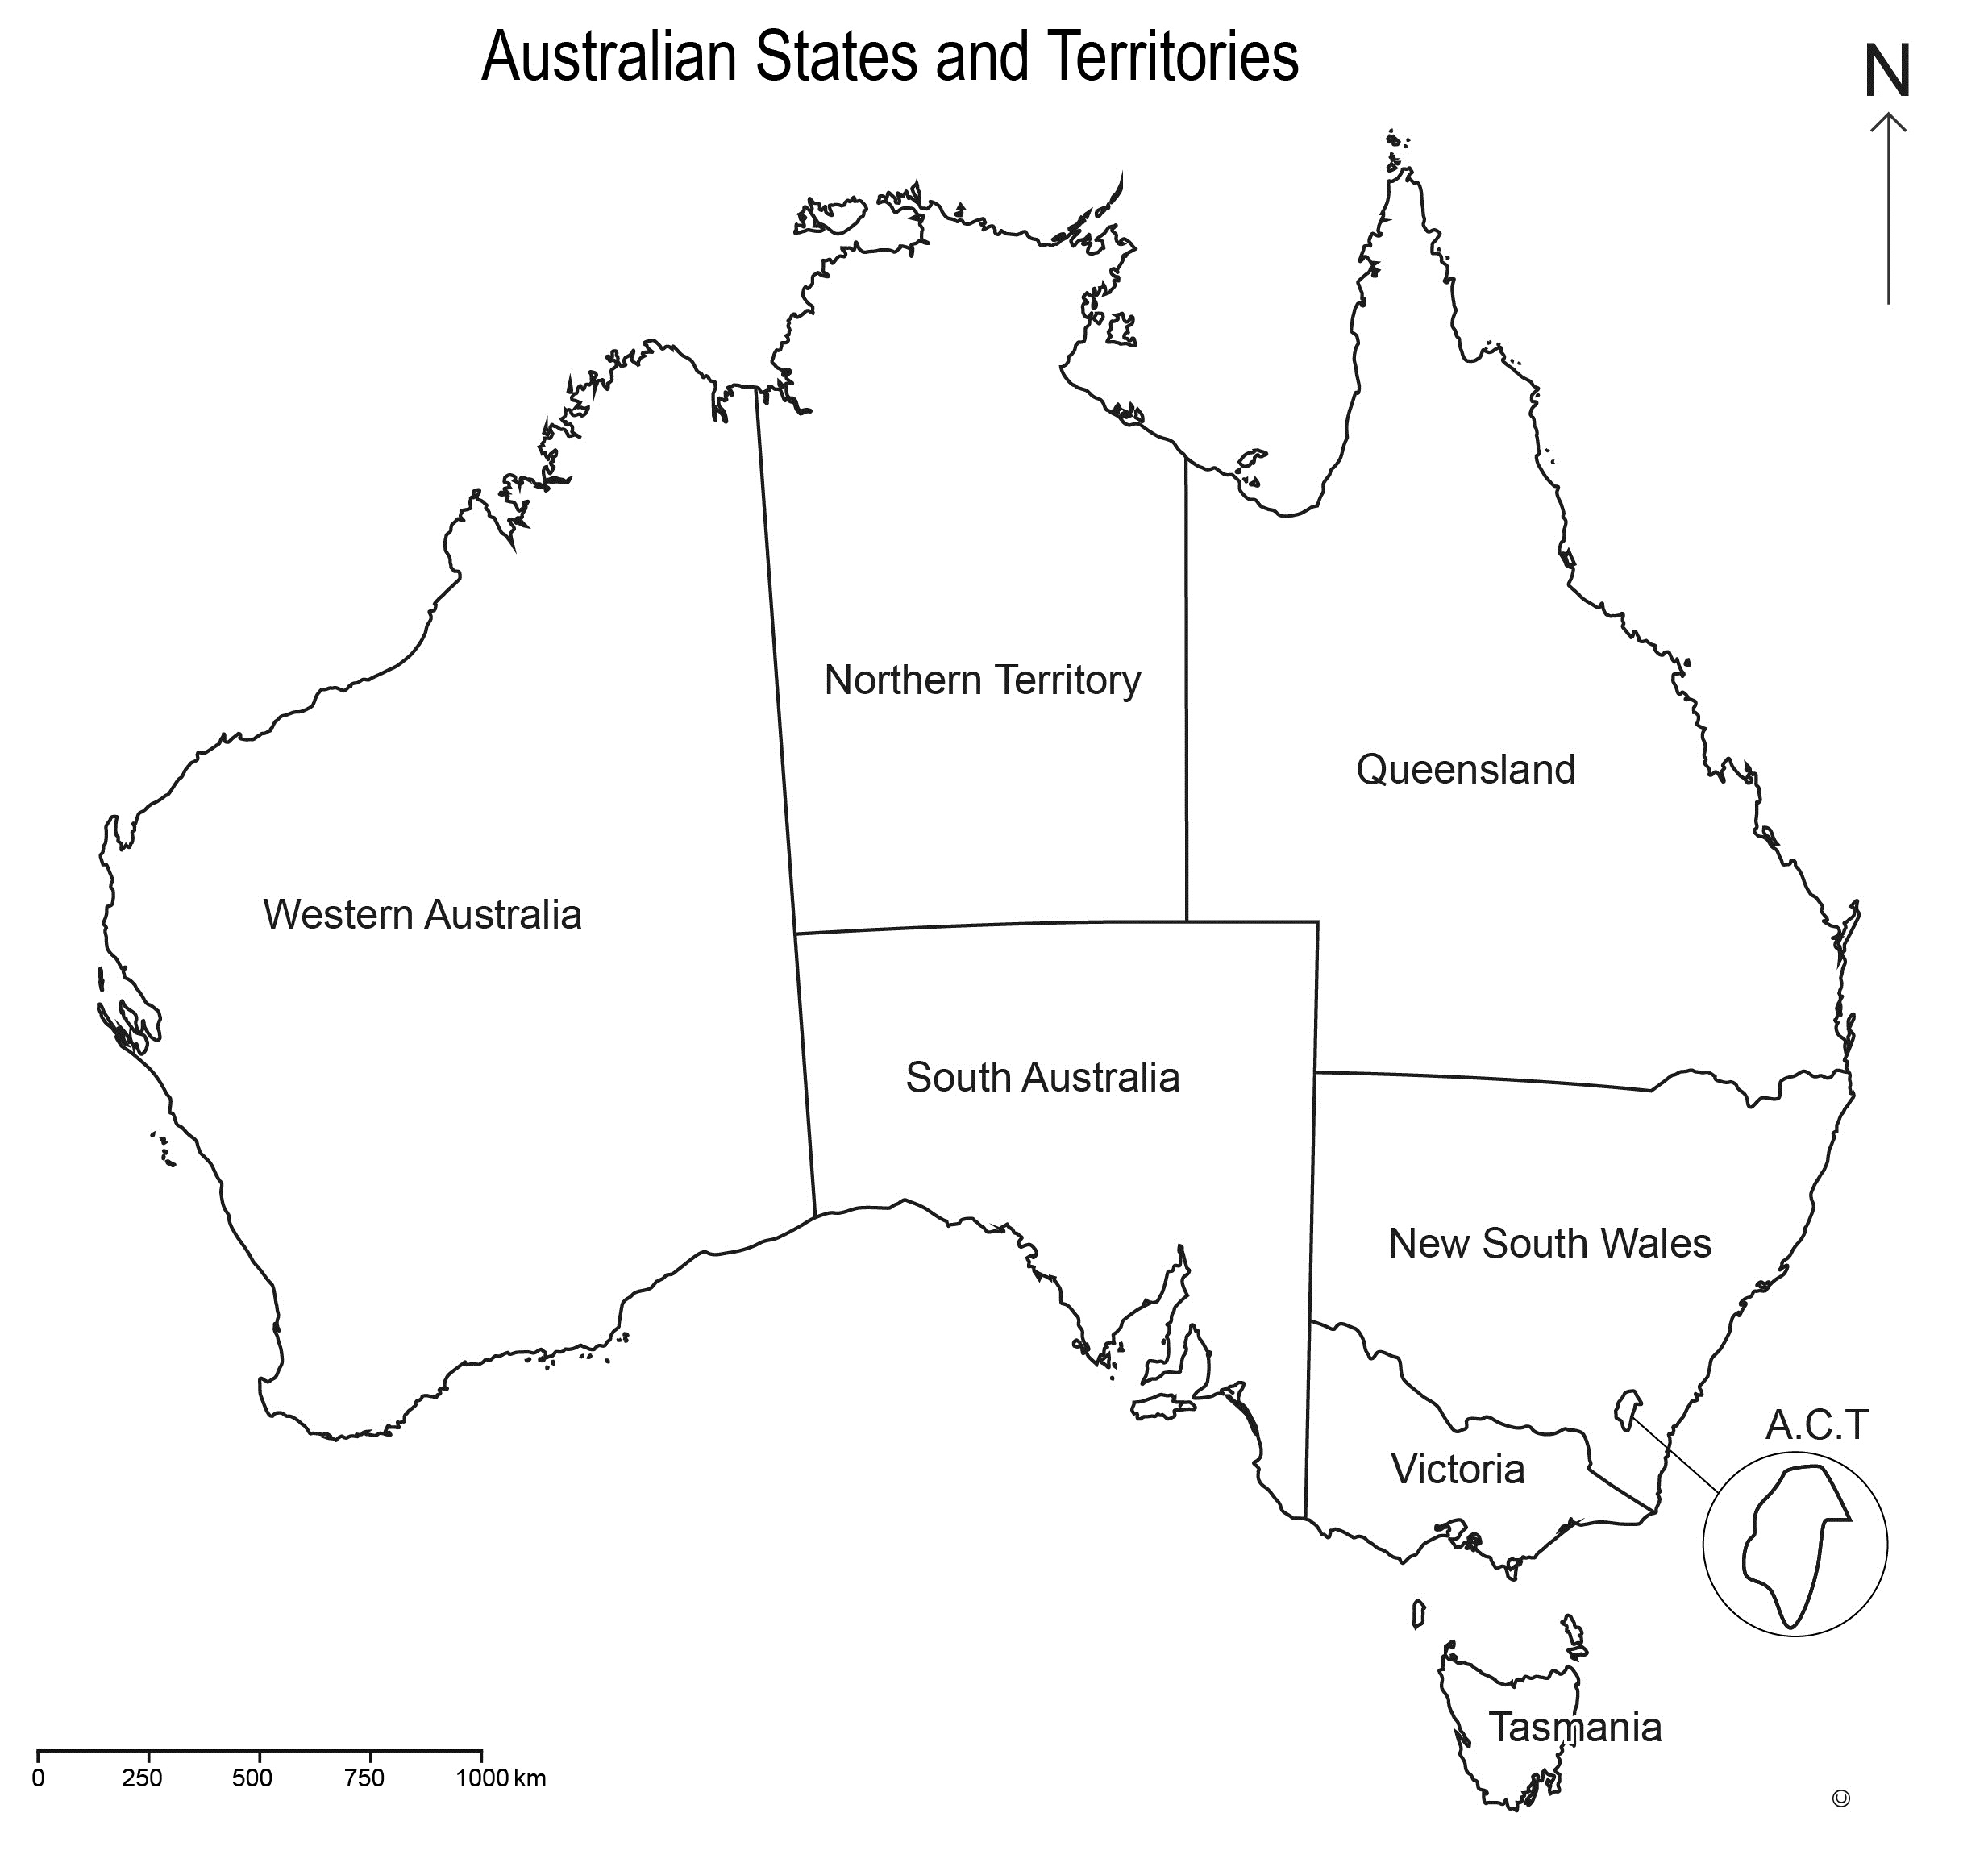 | - ‘Father of Federation’ day – in recognition of Henry Parkes’ achievements in establishing democracy.
 | - Forgotten Children day — in remembrance of the Stolen Generation (MS)
State  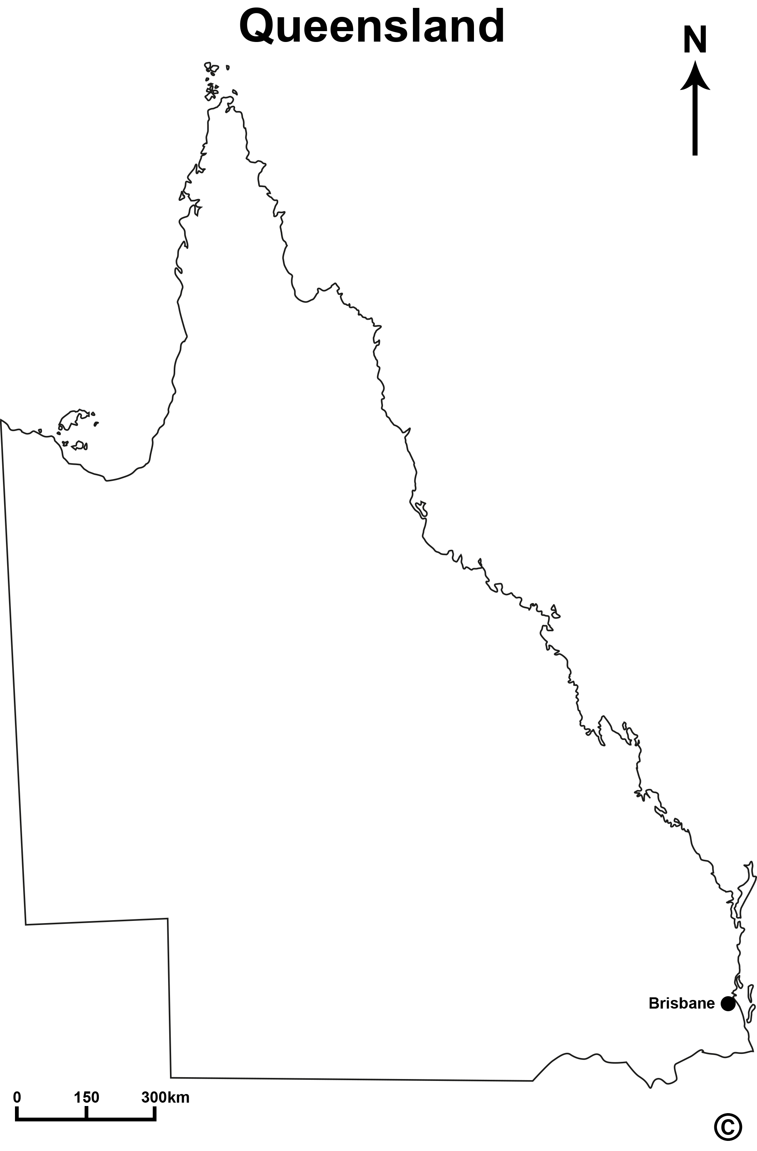 | - State of Origin day — for celebrating or sleeping after we stay up late to watch Queensland win every year! (RT)
 | - Mud Army day — to acknowledge the people who work to help others during natural disasters (SS)
 | - Home Grown Heroes day — to recognise the work of nurses, doctors, paramedics, SES workers and other volunteers (RT)
Local  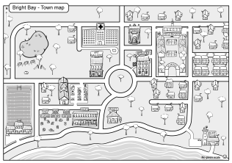 | - Local History Day — where we can all learn about our history and remember our local community groups (MS)
 | - Community Clean-up Day — to ensure local communities take care of their environment (SS)
- Use the criteria below to help you decide on an issue.
This will be demonstrated in their individual explanations and group presentation. Students should submit a graphic organiser or notes of some form that show their collaboration and decision-making process.
- Identify your chosen day and the level of parliament where your idea would be raised. Explain why your group chose this issue.
Answers may vary: As Minister for Human Resources, I propose that the Queensland Parliament should introduce Home Grown Heroes day to recognise the hard work of unseen heroes. This will acknowledge a significant group of Australian heroes who contribute to society in many ways (nurses, doctors, police, paramedics, volunteers, lifesavers, community leaders, etc.) These people have, are and always will be a crucial part of society and without them, many events in history would have ended differently: world wars, natural disasters and even a trip to the beach can result in a desperate need for volunteers and health workers. Businesses would benefit from the public holiday if they chose to open and companies could celebrate the little people through awards ceremonies, lunches and events. This decision is significant, sustainable, ethical and fair and without this change, many people in society will continue to be forgotten.
- Identify arguments for and against this day of recognition.
For | Against
Recognition. | Lots of those people are just doing their job – they get paid for it, why celebrate it?
Award ceremonies and celebrations. | Hospitals would still need to open — some heroes will always miss the celebrations.
Remembrance of events from that year, particularly natural disasters. | How do we force people to use the day for the right reasons? It’s a waste of time.
Affects everyone — relevant to wide variety of people in communities | Shopping centres and businesses lose more money.
- Present your issue. Make sure you address the following:
Presentations should reflect student’s written responses in the assessment task and the criteria listed. The Guide to making judgments should be referred to during presentations and collaboration.
- Explain roles and processes within Australian parliament and how they support the democratic and legal systems.
Answers may vary: Australia is a constitutional monarchy of Britain, which means we are part of the Queen’s Commonwealth government and the Governor-General represents the Queen in government. Our Constitution is reflective of the British Magna Carta and is a three-level parliament (federal, state, local) run by a Prime Minister at the federal level. The State is run by the Premier and local government leaders are called Mayors. Ministers take ideas and changes to Parliament. There are many aspects that make us democratic. The government processes are ruled by a Constitution which was agreed on by the people, all Ministers are voted in by citizens at an election and laws can be changed or introduced by the various Ministers in Parliament if majority rules. If we want to change something in the Constitution, we have to have referendums. A referendum is a democratic voting system to decide on major changes. There have been many significant referendums to improve the democratic nature of Australia.

